# xpedx.com Next generation

# *Order Summary and Order Detail Design Document*

**Authors: Sterling Commerce**

**Date Created:** 05/17/10

**Last Updated:** 06/21/10

**File Name:** C:\Documents and Settings\bfurman\My Documents\Temp\Methodology v1.1\Project Management\TEMPLATE - DOCUMENT - Use Case Definition.docxpedx Order Summary and Order Detail Design v1.4.doc

Approval Signatures (Mandatory)

|  |  |  |  |  |
| --- | --- | --- | --- | --- |
| **Title** | **Name** | **Signature** | **Date** | **Comments / Issues / Concerns** |
| **xpedx Owner(s)** | Steve Bugher |  |  |  |
| Cheryl Tullis |  |  |  |
| **Sterling Commerce Owner(s)** | Guy Read |  |  |  |
|  |  |  |  |

**Note**: The sign off indicates approval of all sections of the document.

Document Revision History

This chart tracks the changes introduced by the revisions to the document as the project progresses through the stages of the System Development Life Cycle (SDLC).

| Version | **Date** | **Description (Changes Made)** | **Author(s)** |
| --- | --- | --- | --- |
| 1.0 | 05/17/2010 | Initial Draft | Sterling |
| 1.1 | 05/18/2010 | Ready to deliver | Sterling |
| 1.2 | 06/07/2010 | Incorporated Feedback | Sterling |
| 1.3 | 06/11/2010 | More feedbacks | Sterling |
| 1.4 | 06/21/2010 | Added Difference in view between Customer Vs Fulfillment order | Sterling |

Related or Reference Documents

| Document Name | Description | Owner | Location |
| --- | --- | --- | --- |
| SCI_Xpedx Solution Definition Document v1.5 | Solution Definition document | Sterling Commerce |  |
|  |  |  |  |

TABLE OF CONTENTS

1. Introduction 4

1.1 Document Purpose 4

1.2 Document Audience 4

2 Order Summary and Details 5

2.1 Functions & Solution 5

2.1.1 Order List Page 5

2.1.2 Order Detail Page 5

2.2 Master System 7

2.3 Implementation Details 7

2.3.1 Entity objects. 7

2.3.2 Actions involved and Functions 7

2.3.3 API Details 8

2.4 Process Flow 8

2.5 Screen Shot 9

2.6 Open Questions 13

2.7 Assumptions 13

3 Glossary of Terms 13

# Introduction

## Document Purpose

This document is the governing functional design document for Order Summary and Order Details functionality. It presents significant decisions and constructs used in developing the functionality. Testing, builds, configuration management are not covered in this document.

The document will also serve the purpose of keeping a list of assumptions that were made during design discussions.

## Document Audience

This document is intended for management and technical staff working on this project, xpedx IT and Business, webMethods, Legacy(MAX and ACCESS), HP, IW, xpedx/IP Network Team. Sterling will use the document during design and configuration for design consideration.

# Order Summary and Details

## Functions & Solution

Orders are confirmed draft orders. Once order is submitted they appear in the users order list page. The user can search from the list, or can see the details of an order by clicking on the order number link. Based on the splitting rules, more than one fulfillment (legacy) orders can be created. In a scenario where there are multiple fulfillment orders, the user can see the original (customer) order as well as the split orders and their details.

## Order List Page

The order list page displays the list of orders the user has placed or is permitted to see. The permission logic could be, all the orders that the user has placed, or all the orders the users for the organization or all order for the organization as well as child organization. There is a business rule which drives the permission at the system level and is not at the user / account level. The results on this page are by defaulted sorted by the last modified date. The results are paginated and 50 orders are shown per page. Please look at the Order List / Approval List Page. The following fields are available on this page:

* Search Orders by - there will be drop down to select following values and text box to enter value.
  + Order # (Either Legacy Order # or Web Confirmation #)
  + PO Number
  + Date Range – From Date/ To Date (two separate fields)
  + Order Status
  + Ship to - they can select Ship To
  + Account - User can select Acct (if they have access to more than one acct).
* Web Confirmation Number (sort able column)
* xpedx Order Number
* Customer PO Number
* Order Date (sort able column)
* Order Owner (sort able column)
* Ship to
* Amount
* Status (sort able column)
* Navigate to the invoice for the order (provided as a link to the user), the site opens a new window with the invoice from R.R. Donnelly. (this link will show up for orders with status Invoiced and the invoice number is available in Sterling)

## Order Detail Page

After an order is placed, a user may want to view the details of the order. For example, a user may want to view the notes added to the order if the user wants to track the changes, if any, made to the order. Please see the Order Detail Page screen in the screen shot section. There are two types of details; one based on the original order using web confirmation number (customer order) for the link, one based on the legacy order (fulfillment order). The fulfillment orders can only be changed and not the customer order.

Sterling Web™ enables a user to view the details pertaining to an order. A user can view header-level information such as the Ship-to, and Bill To addresses, and the shipping option for the order. A user can also view line-level information such as the ID of the line item, short description of the line item, the order line status, requested quantity of the line item, price adjustments, order line total, and so on. A user can also view information about the coupons or promotions, if any, applied to the order and the mode of payment for an order.

Additionally, a user can perform the following actions from the Order Detail page based on user permissions and order status modification rules:

* Navigate to the Item Detail page of a line item: A user can navigate to the Item Detail page by clicking the item description hyperlink. This is allowed only for the items which are present in the catalog. For special items, this feature will not be available.
* Print the Order Detail page: A user can print the Order Detail page.
* E-mail order details: A user can e-mail the details pertaining to an order.
* Reuse an Order: A user can create a new cart from an existing order.
* Edit an order: A user can make changes to an order based on the order status modification rules. Please refer to the Order Change and Cancel in Web channel DDD for the modification rules.
* Cancel an order: A user can cancel an order based on the order status modification rules. Please refer to the Order Change and Cancel in Web channel DDD for the modification rules.
* Link to Return Form.
* The Approve and Reject buttons are displayed only if the user has the permission to approve or reject the order. If an order has already been approved, a user can view the name of the person who has approved the order, by clicking the Approval History hyperlink. This link is displayed if an approval hold exists on an order irrespective of the order status.

Order Detail page will have the following header fields:

* Web Confirmation Number
* xpedx Order Number
* Order Status
* Cancel Order button (depending on the cancel / order modification rules)
* Edit Order button (depending on the cancel / order modification rules)
* Re-Order button
* Returns Item Link
* Approve button (if the order is in pending approval status)
* Reject button (if the order is in pending approval status)
* Ship to address
* Attention Name
* Shipping options
  + Will Call
  + Delivery Hold
  + Requested Delivery Date
* Payment Information
  + Customer PO #
  + Bill to Address
  + Payment Method and information
* Header Comments
* Email Address
* Coupon or Promotion Code (if coupon is applied)
* Line Subtotal
* Adjustments
* Adjusted Subtotal
* Tax
* Shipping Cost
* Total Price of the order

Order Detail page will have the following line level fields:

* Product Image (for catalog items)
* Product Name (with hyperlinks to product detail page, only for the catalog skus)
* Product description
* Xpedx sku #
* Customer xku# (if applicable)
* Manufacturer sku# (if applicable)
* Master Product Code (if applicable)
* Line notes
* Quantity (Requested Qty)
* UOM (Requested UOM)
* Backordered and shipped quantity if viewing legacy order.
* Customer fields 1,2,3 along with Account line number (based on customer profile)
* Status
* Unit price (based on requested UOM and qty) and price in price UOM if different from requested UOM
* Extended Price
* Adjustments
* Line Total (based on requested UOM and qty)

## Differences in View between Customer Order Vs Fulfillment Order

There are two types of order details, Customer order which is a consolidated view of the order placed by the customer. And fulfillment order which is a view of the order as stored in Legacy. The major differences in view between these are:

* Cancel Order button – Cancel Order button will be present in the Fulfillment order and not in Customer order.
* Edit Order button – Edit Order button will be present in the Fulfillment order and not in Customer order.
* Shipped Qty, Backorder Qty columns will show up on the Fulfillment orders and not in Customer order
* Split Order information at line level – At the line level, if the line is split into different fulfillment orders, the customer order will show the qty and fulfillment order #s for that line.

## Master System

Legacy is the master of system for fulfillment Orders and Sterling is the master of system for customer orders.

## Implementation Details

## Entity objects.

Following custom entities are added to support the functionality

* XPX_ORDER_Extensions.xml – this has order and line level custom fields for an order.

## Actions involved and Functions

Following new Actions are introduced to achieve the required functionality on top of OOTB

* XPEDXOrderListAction.java – The action class XPEDXOrderListAction extends the OOTB class OrderListAction to get the list of orders for a user.
* XPEDXOrderApprovalAction.java – The action class XPEDXOrderApprovalAction extends the OOTB class OrderApprovalAction and gets the list of pending approval orders for a user.

## API Details

Following APIs will be called to achieve the functionality.

* getCompleteOrderDetails - The getCompleteOrderDetails API is called to retrieve the details of an order.

## Process Flow

Not Applicable

## Screen Shot

The screen shots pasted here are still in review and not final. This is just an illustration of how it should look like.

***Order List Page***

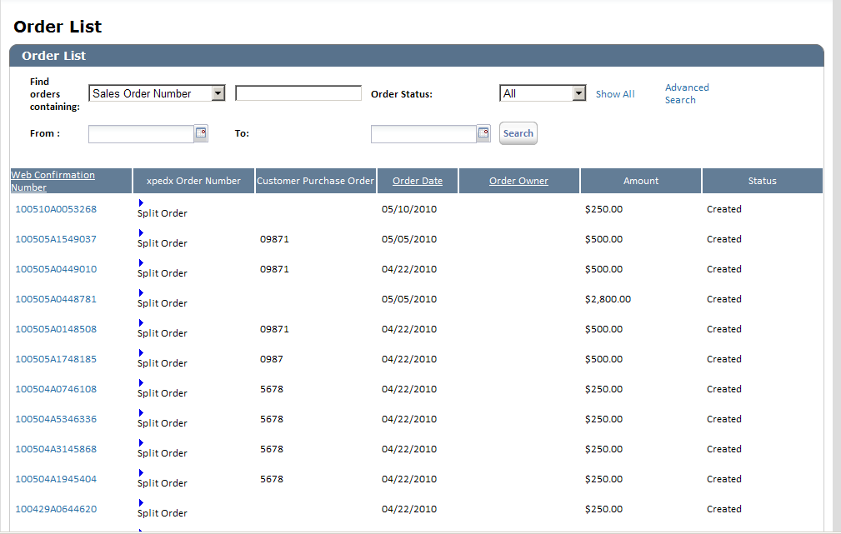

***Approval List Page***

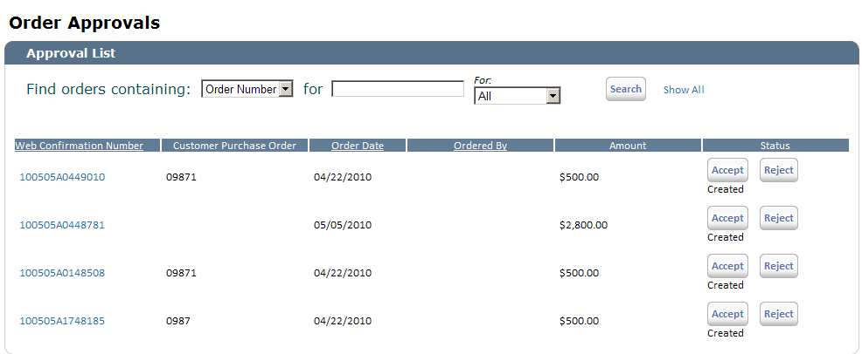

***Order Detail Page***

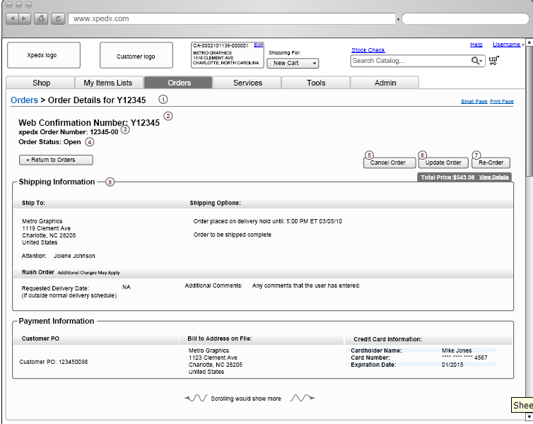

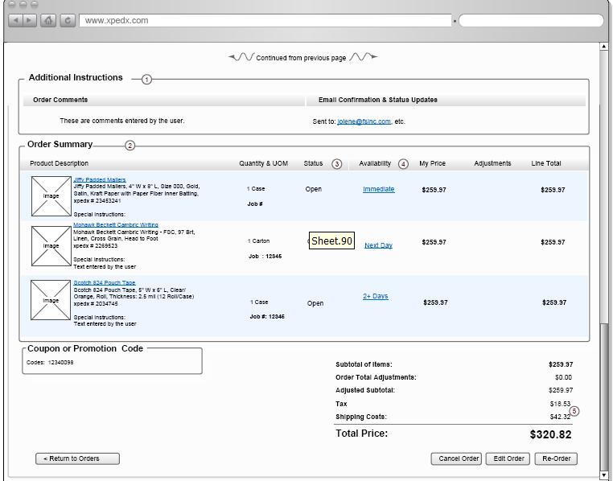

## Open Questions

1. Why do we need to show the availability column in the order detail page? At this point does it make sense? Answer: George agrees, Chris to confirm.
2. Current IW screen for the order list page has a search box for searching orders by Order #, PO Number etc. The UI needs to be corrected to have a drop down to choose what the user wants to search for with a text box corresponding to it to enter the search value. Answer: IW to change the screen
3. Order List / Search page needs to have two text boxes for the date range search instead of one single box. Answer: IW to change the screen
4. Do we have a screen for Customer Order detail page? (When you click on the web confirmation number). How is it different in terms of look and feel wise from the fulfillment order. One difference I can think of is the cancel and change order buttons will not be present in the customer order. If there are more differences, please provide a screen for the same.

## Assumptions

1. The pending approval orders will not be sent to Legacy unless they are approved and ready to go.

# Glossary of Terms

|  |  |  |
| --- | --- | --- |
| S. No. | Term | Definition |
| 1. | Entity Object | Database and Java entity objects to store the required data. |
| 2. | Action Class | Struts controllers which redirects the parameters and does some business logic before calling the business APIs. |
| 3. | BR1 | Business Release 1 |
| 4. | IW | Industrial Wisdom – UI firm engaged on the project. |
| 5. | Quick Add | Quick way of adding items to the cart or list. |
|  |  |  |